Exercise 2: Projections & Coordinate Systems

Jatin Chowdhary

Lab Section #03

Wednesday, October 18th, 2017

Michele Tsang

1. I used Decimal Degrees as map units because the layers in the data frame have geographic coordinate systems. GCS uses a three-dimensional spherical surface to define locations on the earth, making it ideal to measure reference locations on Earth's surface.

2. I used Degrees Minutes Seconds because it's what longitude and latitude are measured in. Using the center of the Earth (Prime Meridian & Equator) as a frame of reference, every location can be indexed with precise coordinates.

3. Darwin's coordinates are: 130o59'40.366"E & 12o42'5.367"S.

4. Darwin's coordinates are: 14582.247 Kilometers, -1413.925 Kilometers. This means that Darwin is about 14582km East of the Prime Meridian, and 1413km South of the Equator.

5. All of the layers [i.e. Ocean, Lakes, Countries, and Rivers] disappeared. The only thing remaining on the screen are the 4 cities' names [Churchill, Stockholm, Brasilia, Darwin].

6. After pressing the globe icon, all of the layers that were missing in question #5, came back, but the cities' names disappeared.

7. The Eckert II projection is a pseudo cylindrical projection (looks like a hexagon), where the area is preserved but shape isn't. The direction is distorted everywhere, and discontinuities exist at the equator. The parallels are unequally spaced straight lines. Meridians are equally spaced straight lines. The poles and central meridian are straight lines half as long as the equator.

8.

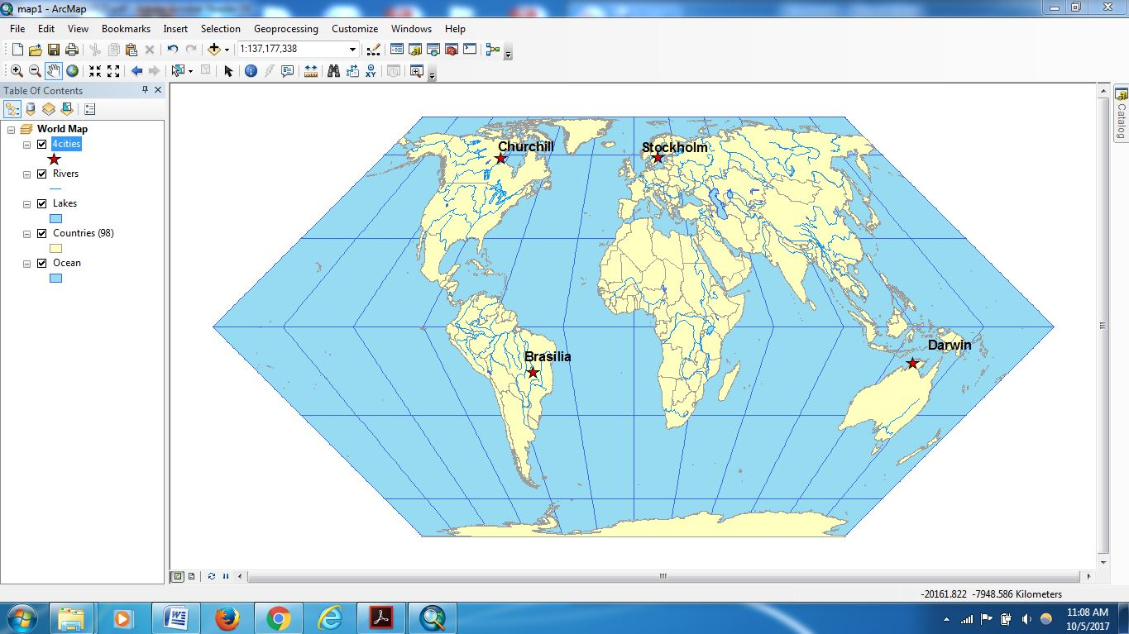

9. Distance from projection's origin to *city* (measured in meters) is:

* Churchill: 9,384,866.769579
* Brasilia: 4,813,749.258442
* Stockholm: 7,535,683.26712
* Darwin: 12,379,895.061795

10.

|  |  |  |  |  |
| --- | --- | --- | --- | --- |
| Country | SQKM_CNTRY (km2) | Eckert II (km2) | Mercator (km2) | Robinson (km2) |
| Argentina | 2781013 | 2787418 | 4294388 | 2613048 |
| China | 9338902 | 9388283 | 14851939 | 8881386 |
| Kenya | 584429 | 585778 | 582762 | 476803 |
| United Kingdom | 243137 | 243845 | 712940 | 270234 |

11. Eckert II preserves area. Mercator preserves area if the country is near the equator; polar regions (areas away from the Equator) are distorted. Robinson preserves area; better than Mercator but not as good as Eckert II.

12. Eckert II is only useful as novelty. Mercator is good for directional uses such as air travel, wind direction, and ocean currents. Mercator is the standard for sea navigation charts and it's used for conformal world maps. Robinson was developed for general use and thematic maps.

13. The coordinate system of this data frame is: GCS_North_American_1983

14. The projection associated with NAD 1983 Statistics Canada Lambert coordinate system is: Lambert_Conformal_Conic

15.

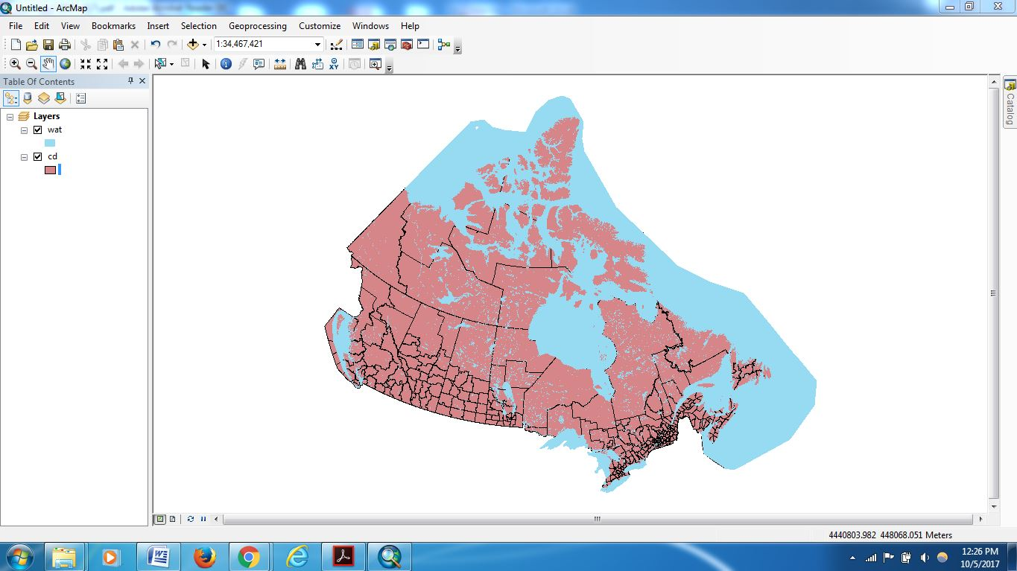

16. From the Menu toolbar, select View, then Data Frame Properties. Navigate to the Coordinate System tab and at the bottom it'll say: "No coordinate system". You can also browse the properties of each layer, and in the Source tab, it'll say "<undefined>" for the Coordinate system.

17. Hamilton's UTM Zone is 17N.

18.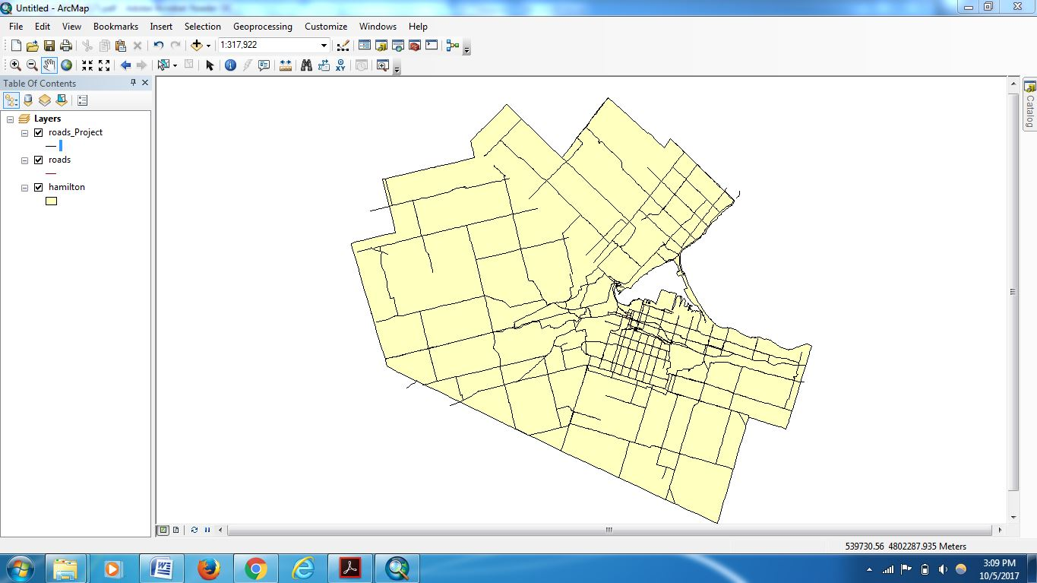

19. The datum for Roads27 is: D_North_American_1927

20. The datum for Roads83 is: D_North_American_1983

21. The distance between NAD27 and NAD83 in the north-south direction is 9.59m, and 16.79m in the east-west direction.